**Module 5: Conic Sections and Polar Coordinates**

**I. The Parabola**

After completing this section, you should be able to:

* list the types of conic sections
* identify the vertex, focus, directrix, and axis of symmetry of a parabola
* transform an equation of a parabola into standard form
* graph a parabola

**Conic Section**

A **conic section** is a curve formed by the intersection of a plane and a [right circular cone with two parts](https://umuc.equella.ecollege.com/file/51ed41e5-be80-4110-8171-a40ed58c98af/1/MATH108-0609.zip/Modules/M5-Module_5/popups/Conic_Section.html). There are four basic conic sections: the **parabola**, **circle**, **ellipse**, and **hyperbola**. Each of these is shown below.

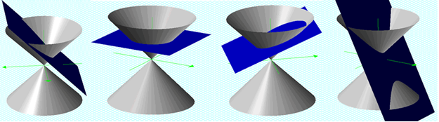

If the plane intersects one portion of a cone and is parallel to a line on the cone, the intersection is a parabola. If a plane intersecting the cone is perpendicular to the axis of the cone, the intersection is a circle. If the plane is tilted so that it intersects one portion of the cone, is not perpendicular to the axis, and is not parallel to a line on the cone, the intersection is an ellipse. If the plane intersects both portions of a cone, the intersection is a hyperbola.

You have studied some aspects of circles and parabolas in college algebra (reviewed in module 1, topics I-D and II-E), so some portions of the discussion of conic sections should be very familiar.

A conic section can be represented algebraically by a second-degree equation of the form

*Ax*2 + *Bxy* + *Cy*2 + *Dx* + *Ey* + *F* = 0

where *A*, *B*, *C*, *D*, *E,* and *F* are constants.

Certain relationships between the coefficients determine the type of conic section represented by the equation. Each type of conic section has a geometric characterization as well as an algebraic characterization.

**Geometric Definition of a Parabola**

A **parabola** is the set of points in the plane equidistant from a fixed line (the **directrix**) and a fixed point (the **focus**) not on the directrix.

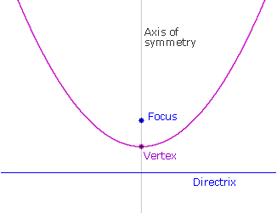

The **axis of symmetry** of a parabola is the line through the focus that is perpendicular to the directrix. The **vertex** of a parabola is the midpoint of the line segment between the focus and the directrix.

**Standard Equation of a Parabola with Vertex (0, 0)**

Using the geometric definition of a parabola, an equation can be derived.

First, consider a simple case where the vertex is the origin (0, 0) and the focus *F* is the point (0, *p*), so the axis of symmetry is the *y*-axis. The directrix must be the line *y* = –*p* since the vertex is equidistant between the focus and the directrix. The parabola opens upward. Now pick an arbitrary point *P*: (*x*, *y*) on the parabola.

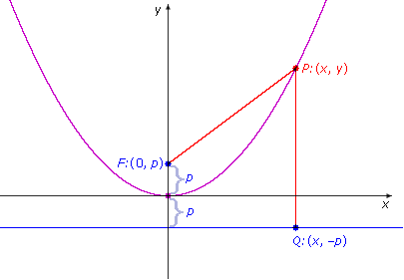

Consider the line passing through *P* that is perpendicular to the directrix. Let *Q* be the point of intersection of the two lines. *Q* has coordinates (*x*, –*p*). The distance between *P* and the directrix is *PQ*.

Since *P* is equidistant between the focus *F* and the directrix, the distance *PF* is equal to the distance *PQ*.

|  |  |
| --- | --- |
| *PF* = *PQ* |  |
| https://umuc.equella.ecollege.com/file/51ed41e5-be80-4110-8171-a40ed58c98af/1/MATH108-0609.zip/Modules/M5-Module_5/images/distance_formula.gif | Apply the distance formula. (See module 1, topic I-B  for a review of the distance formula.) |
| *x*2 + (*y* – *p*)2 = 0 + (*y* + *p*)2 | Square both sides. |
| *x*2 + *y*2 – 2*py* + *p*2 = *y*2 + 2*p*y + *p*2 | Multiply out each side. |
| *x*2 = 4*py* | Simplify so that the variables *x* and *y* appear on  opposite sides of the equation. |

This equation is an algebraic representation of a parabola that has its vertex at the origin and a vertical axis of symmetry. A similar equation can be derived for a parabola with vertex at the origin and a horizontal axis of symmetry. The results are summarized below.

|  |  |
| --- | --- |
| **Standard Equation of a Parabola with Vertex (0, 0)** | |
| **Vertical Axis of Symmetry** | |
| *x*2 = 4*py*  Focus: (0, *p*)           Directrix *y:* = –*p*                       Axis of symmetry: *y*-axis | |
| If *p* > 0, the parabola opens upward.  https://umuc.equella.ecollege.com/file/51ed41e5-be80-4110-8171-a40ed58c98af/1/MATH108-0609.zip/Modules/M5-Module_5/images/standard-eq-parab1.png | If *p* < 0, the parabola opens downward.  https://umuc.equella.ecollege.com/file/51ed41e5-be80-4110-8171-a40ed58c98af/1/MATH108-0609.zip/Modules/M5-Module_5/images/standard-eq-parab2.png |
| **Horizontal Axis of Symmetry** | |
| *y*2 = 4*px*  Focus: (*p*, 0)                Directrix: *x* = –*p*                       Axis of symmetry: *x*-axis | |
| If *p* > 0, the parabola opens to the right.  https://umuc.equella.ecollege.com/file/51ed41e5-be80-4110-8171-a40ed58c98af/1/MATH108-0609.zip/Modules/M5-Module_5/images/standard-eq-parab3.png | If *p* < 0, the parabola opens to the left.  https://umuc.equella.ecollege.com/file/51ed41e5-be80-4110-8171-a40ed58c98af/1/MATH108-0609.zip/Modules/M5-Module_5/images/standard-eq-parab4.png |

**Example I.1:** If the focus of a parabola is (3, 0) and the directrix is the line *x* = –3, find the standard equation of the parabola and graph the equation.

**Solution:**

Since the axis of symmetry passes through the focus (*p*, 0) = (3, 0) and is perpendicular to the directrix *x* = –3, the axis of symmetry must be the *x*-axis. The vertex is the midpoint of the line segment between (3, 0) and the line *x* = –3, so the vertex must be (0, 0). The parabola opens to the right.

Therefore, the standard equation must have the following form:

|  |  |
| --- | --- |
| *y*2 = 4*px* |  |
| *y*2 = 4(3)*x* | Substitute *p* = 3. |
| *y*2 = 12*x* | Simplify. |

The graph is shown below.

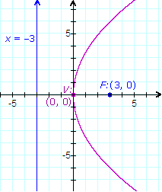

**Example I.2:** Given the equation https://umuc.equella.ecollege.com/file/51ed41e5-be80-4110-8171-a40ed58c98af/1/MATH108-0609.zip/Modules/M5-Module_5/images/mod5-exI-2.gif, find the focus, directrix, vertex, and axis of symmetry. Graph the parabola.

**Solution:**

First, rewrite the equation https://umuc.equella.ecollege.com/file/51ed41e5-be80-4110-8171-a40ed58c98af/1/MATH108-0609.zip/Modules/M5-Module_5/images/mod5-exI-2.gif in standard form, with the squared variable, *x*2, isolated on one side of the equation:

|  |  |
| --- | --- |
| https://umuc.equella.ecollege.com/file/51ed41e5-be80-4110-8171-a40ed58c98af/1/MATH108-0609.zip/Modules/M5-Module_5/images/mod5-exI-2.gif |  |
| –20*y* = *x*2 | Multiply both sides by –20. |
| *x*2 = –20*y* | For convenience, put the squared term on the left side. |
| *x*2 = 4(–5)*y* | Convert into standard form: *x*2 = 4*py*. |

Therefore, *p* = –5 and the vertex is the origin (0, 0).

Since the equation has an *x*2 term (and no *y*2 term), the axis of symmetry is vertical. The axis of symmetry is the *y*-axis. Since *p* = –5, the parabola opens downward

The focus is (0, *p*) = (0, –5). The directrix is the line *y* = –*p* = –(–5) = 5.

The graph is shown below.

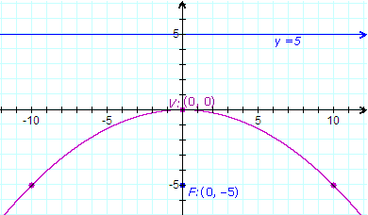

**Standard Equation of a Parabola with Vertex (*h*, *k*)**

Suppose the vertex of a parabola is the point (*h*, *k*) and the focus is (*h*, *k* + *p*). The axis of symmetry passes through these points, so it must be the vertical line *x* = *h*.

To go from a vertex of (0, 0) in the simple case to the vertex of (*h*, *k*), shift horizontally by *h* units and vertically by *k* units. To go from a focus of (0, *p*) in the simple case to the focus of (*h*, *k* + *p*), also shift horizontally by *h* units and vertically by *k* units. Now apply the same procedure to the standard equation.

|  |  |
| --- | --- |
| *x*2 = 4*py* | Standard form for a parabola with vertex (0, 0) and focus (0, *p*). |
| https://umuc.equella.ecollege.com/file/51ed41e5-be80-4110-8171-a40ed58c98af/1/MATH108-0609.zip/Modules/M5-Module_5/images/mod5-parabolaformula.gif | Solve for *y*. |
| https://umuc.equella.ecollege.com/file/51ed41e5-be80-4110-8171-a40ed58c98af/1/MATH108-0609.zip/Modules/M5-Module_5/images/mod5-parabolaformula-1.gif | *y* is written as a function of *x.* |
| https://umuc.equella.ecollege.com/file/51ed41e5-be80-4110-8171-a40ed58c98af/1/MATH108-0609.zip/Modules/M5-Module_5/images/mod5-parabolaformula-2.gif | Replace *x* with *x* – *h* to shift the graph of the function horizontally by *h* units. (See module 1, topic III for a review of translation of functions and graphs.) |
| https://umuc.equella.ecollege.com/file/51ed41e5-be80-4110-8171-a40ed58c98af/1/MATH108-0609.zip/Modules/M5-Module_5/images/mod5-parabolaformula-3.gif | Add *k* to shift the graph vertically by *k* units. |
| https://umuc.equella.ecollege.com/file/51ed41e5-be80-4110-8171-a40ed58c98af/1/MATH108-0609.zip/Modules/M5-Module_5/images/mod5-parabolaformula-4.gif | Subtract *k* from both sides. |
| 4*p*(*y* – *k*) = (*x* – *h*) 2 | Multiply both sides by 4*p*. |
| (*x* – *h*)2 = 4*p*(*y* – *k*) | Rewrite with the squared quantity on the left side. |

Notice that the *x* in the simple case *x*2 = 4*py* has been replaced by *x* – *h* in the general case, and *y* has been replaced by *y* – *k*.

A similar equation can be derived for a parabola with vertex at (*h*, *k*) and a horizontal axis of symmetry. The results are summarized below.

|  |  |
| --- | --- |
| **Standard Equation of a Parabola with Vertex (*h*, *k*)** | |
| **Vertical Axis of Symmetry** | |
| (*x* – *h*)2 = 4*p*(*y* – *k*)  Focus: (*h*, *k* + *p*)  Directrix: *y* = *k* – *p*  Axis of symmetry: *x* = *h*  If *p* > 0, the parabola opens upward.  If *p* < 0, the parabola opens downward. | https://umuc.equella.ecollege.com/file/51ed41e5-be80-4110-8171-a40ed58c98af/1/MATH108-0609.zip/Modules/M5-Module_5/images/Graphs/standard-eq-parab5.png  The graph illustrates the case when *p* > 0. |
| **Horizontal Axis of Symmetry** | |
| (*y* – *k*)2 = 4*p*(*x* – *h*)  Focus: (*h* + *p*, *k*)  Directrix: *x* = *h* – *p*  Axis of symmetry: *y* = *k*  If *p* > 0, the parabola opens to the right.  If *p* < 0, the parabola opens to the left. | https://umuc.equella.ecollege.com/file/51ed41e5-be80-4110-8171-a40ed58c98af/1/MATH108-0609.zip/Modules/M5-Module_5/images/Graphs/standard-eq-parab6.png  The graph illustrates the case when *p* > 0. |

An equation of a parabola can have an *x*2 term or a *y*2 term, but not both.

If you start with an equation of a parabola that is not in standard form, you can transform it to standard form by completing the square. (See module 1, topic I-C to review this technique.)

**Example I.3:** Completing the square, and analyzing and graphing a parabola, given its equation in general form

Given the following equation of a parabola, find the vertex, focus, and direction. Graph the parabola.

*y*2 + 4*y* – 8*x* + 28 = 0

Solution:

**Step 1**: Transform the equation to standard form **(*y* – *k*)2 = 4*p*(*x* – *h*)** by completing the square.

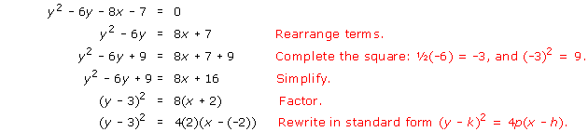

**Step 2**: In the standard form, the equation is

(*y*–(–2))2 = 4(2)(*x*– 3)

The vertex *V*: (*h*,*k*) = (3, –2) and *p* = 2.

The equation has a *y*2 term (and no *x*2 term), so the axis of symmetry is horizontal.   
The axis of symmetry is the line *y* = *k* = –2.

Since *p* = 2, the focus is 2 units to the right of the vertex, on the axis of symmetry. The focus is *F*: (3 + 2, –2) = (5, –2). The directrix is 2 units to the left of the vertex. The directrix is the line *x* = 3 – 2 = 1.

The graph is shown below.

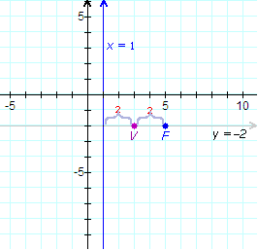

**Step 3**: Given the location of the focus and directrix, the parabola must open to the right.

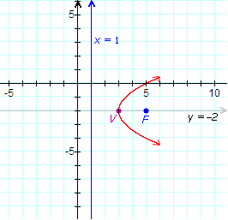

**Step 4**: Take the equation (*y* + 2)2 = 8(*x* – 3) and plot a few points to get an accurate graph of the parabola.

Since *p* = 2, and the parabola opens to the right, two points on the graph must be located 2*p* = 2(2) = 4 units above and below the focus (5, –2). Therefore, two points are (5, –2 + 4) = (5, 2) and (5, –2 –4) = (5, –6).

Alternatively, if *x* = 5, then (*y* + 2)2 = 8(*x* – 3) =8(2) = 16, and *y* + 2 = 4 or –4. So, *y* = −2 + 4 = 2 or *y* = −2 – 4 = −6. Therefore, (5, 2) and (5, −6) are points on the graph.

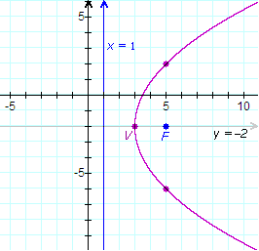

Many applications involve parabolas. Optical aids such as flashlights, and communications devices such as satellite dishes use parabolic reflectors to focus light, sound, or radio waves.

[*Return to top of page*](https://umuc.equella.ecollege.com/file/51ed41e5-be80-4110-8171-a40ed58c98af/1/The%20Parabola.html#pagetop)

[**Report broken links or any other problems on this page.**](http://help.umuc.edu/)  
  
[**Copyright © by University of Maryland University College.**](https://umuc.equella.ecollege.com/file/51ed41e5-be80-4110-8171-a40ed58c98af/1/MATH108-0609.zip/common/copyright.html)